JBoss BRMS
Customer Evaluation Demo
(Rules integration with BPM)

Eric D. Schabell
JBoss Technology Evangelist (Integration & BPM)
Table of Contents
Introduction 2
Setup and Configuration 2
Installation 2
JBoss Developer Studio Configuration 4
Start the JBoss Enterprise BRMS Platform 5
Importing Project Repository into BRM 6
Running the Demo 6
JBDS IDE demo 6
BRMS BRM demo 8
Web Designer 8
Rule asset viewing 8
Build package for deployment 8
Business Central 9

Introduction
This is a BRMS demo application setup guide for the Customer Evaluation Demo. The setup will create a fully installed and configured BRMS environment so that you can demo the project in all the available BPM components.

It will provide you with a JBoss Developer Studio project with unit tests to demo the project in the IDE. It will also provide a repository that you can import into BRMS BRM and demo the web tooling, web business central admin console and asset manager BRM tooling for business users.

Setup and Configuration

Installation
You first need to get the project by cloning it from the central location:

git clone –branch jdf-quickstart git://github.com/eschabell/brms-customer-evaluation-demo.git

Once downloaded, you will have the following folder structure:
- \brms-customer-evaluation-demo
  - \installs – Initially empty, but will contain the BRMS platform downloads and the fully configured BRMS runtime server.
  - \projects – The project that comprise the demo.
  - \support – Additional supporting files used by the demo.
  - init.sh – Script to install and configure the run time server environment.
  - Quick Start Guide.odt – This document
Next, download JBoss Enterprise BRMS Platform from the Red Hat Customer Portal (https://access.redhat.com/jbossnetwork).
Download BRMS Platform:
- Under JBoss Enterprise Platforms, select the BRMS Platform product.
- Select version 5.3.1 in the Version field.
- Download JBoss BRMS 5.3.1 Deployable for EAP 6
(Please note that this is the deployable distribution, not the standalone one.)

Now copy brms-p-5.3.1.GA-deployable-ee6.zip, to the brms-rewards-demo's installs folder.

Download EAP 6 Platform:
- Under JBoss Enterprise Platforms, select the Application Platform product.
- Select version 6.1.0.Beta in the Version field.
- Download JBoss Aplication Platform 6.1.0.

Now copy jboss-eap-6.1.0.zip, to the brms-rewards-demo's installs folder.
Lastly, from the brms-rewards-demo folder, run the init.sh script:

$ ./init.sh

When the script completes you will have a new folder named jboss-eap-6.1, in the brms-rewards-demo's installs folder. The folder is a ready to run EAP 6 server with BRMS 5.3.1 with the following modifications made:
- The admin, krisv, mary, john, erics accounts enabled (passwords are same as users name) in the brms-roles.properties and brms-users.properties file in brms-customer-evaluation-demo/installs/jboss-eap-6.1/jboss-as/standalone/configuration
- The security settings modifed by copying components.xml to brms-customer-evaluation-demo/installs/jboss-eap-6.1/standalone/deployments
- Adjusted server security domain to include brms, copied new standalone.xml to brms-customer-evaluation-demo/installs/jboss-eap-6.1/jboss-as/standalone/configuration
- The custom work items are activated by adding CustomWorkItemHandlers.conf and drools.session.conf to the jbpm-gwt-console-server at brms-customer-evaluation-demo/installs/jboss-eap-6.1/standalone/deployments/business-central-server.war/WEB-INF/classes/META-INF
- The domain model jar customereval-model.jar added to the console at brms-customer-evaluation-demo/installs/jboss-eap-6.1/deployments/jbpm-gwt-console-server.war/WEB-INF/lib
- Enable users in human task server by copying new jbpm-human-task-war-web.xml file to brms-customer-evaluation-demo/installs/jboss-eap-6.1/jboss-as/standalone/deployments/jbpm-human-task.war/WEB-INF/web.xml
- Both business-central-server and jbpm-human-task server needs a netty dependency, added a MANIFEST.MF to their repective WEB-INF/classes/META-INF directories

JBoss Developer Studio Configuration
In this section, you will configure JBoss Developer Studio. Specifically you will add the BRMS 5.3.1 platform server runtime environment and then import the project that makes up the BRMS Customer Evaluation Demo.
Important: It is assumed that you already have JBoss Developer Studio installed. This demo has been tested with JBoss Developer Studio 7.0.0.Beta1
Launch JBoss Developer Studio
- Either select or switch to a new workspace by pointing to the brms-customer-evaluation-demo/projects folder.
- If the Welcome to JBoss Developer Studio screen appears, dismiss it by click the Workbench arrow in the upper right.
Install SOA tools for BRMS
- Select Help → Install New Software... and add SOA Tools update site:
http://download.jboss.org/jbosstools/updates/integration/kepler/integration-stack/aggregate/4.1.0/
- Select Business Process and Rules Development & SOA Development (all sub-menu items will be selected) and proceed thru installation and restart JBoss Developer Studio to complete the installation. You will be told to restart JBoss Developer Studio for the changes to take effect, do this now.
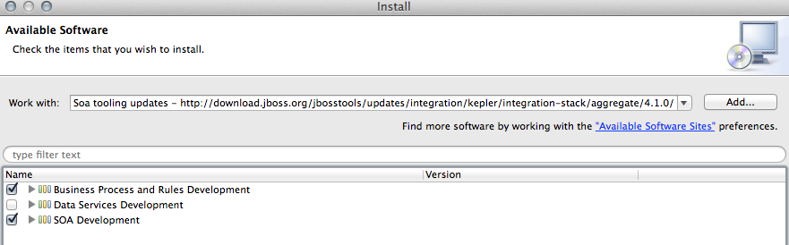
Detect and add a BRMS 5.3.1 runtime environment
- Select Preferences from the Window menu.
- In the left hand side, expand JBoss Tools and then select JBoss Tool Runtime Detection
- Select the Add button and navigate to the brms-customer-evaluation-demo/installs folder, then select OK.
- The jboss-eap-6.1 runtime created earlier should have been found and selected. If so, select OK.
- Select OK again to close the Preferences dialog window.
Import Projects
- Select Import... from the File menu.
- Expand the Maven folder, and then select Existing Maven Projects.
- Select the Browse button to Select root directory, you should be in the brms-customer-evaluation-demo folder (if not, then navigate there) and then select OK.
- Make sure the project (brms-customer-evaluation-demo) is selected and then select Finish.
- The projects are now imported.

Start the JBoss Enterprise BRMS Platform
In this section, you will start the server from within JBoss Developer Studio.
- Select the Servers view
If it is currently not open, select Show View --> Other... from the Window menu and search for the Servers view.
- You should see the jboss-eap-6.1 server you created earlier.
- Right click on jboss-eap-6.1 and select Start from the pop-up menu. In a few moments your JBoss Enterprise BRMS Platform will be running.

Importing Project Repository into BRM
In this section, you will import all of the JBoss Enterprise BRMS artifacts into the Business Rules Manager.
- Open up your Web browser of choice and navigate to http://localhost:8080/jboss-brms/
- Use the default credentials of admin/admin
- Upon logging in, you will see the following prompt:
This looks like a brand new repository.
Would you like to install a sample repository?
Important: Please be sure to select No thanks.
- Select the Administration section on the left hand side
- From the Administration list select Import Export. This will open the Import Export window.
- Now select Browse... and navigate to brms-customer-evaluation-demo/support folder and select the repository_export.zip file.
  - Optional import of a declarative domain model (where your model is in the BRM package and not an uploaded jar of your Java objects) can be found by importing repository_export_declarative_model.zip file.
- Lastly, select the Import button. Select OK to confirm that you want to import the artifacts.

Running the Demo

JBDS IDE demo
You can demo the project in the JBoss Developer Studio by making use of the editors, running the provided unit tests and watching the console for logged (verbose) output. The following will run the demo process with four unit tests:
- Select the file brms-customer-evaluation-demo/src/test/java/CustomerEvaluationTest.java, right click, Run As..., JUnit Test.
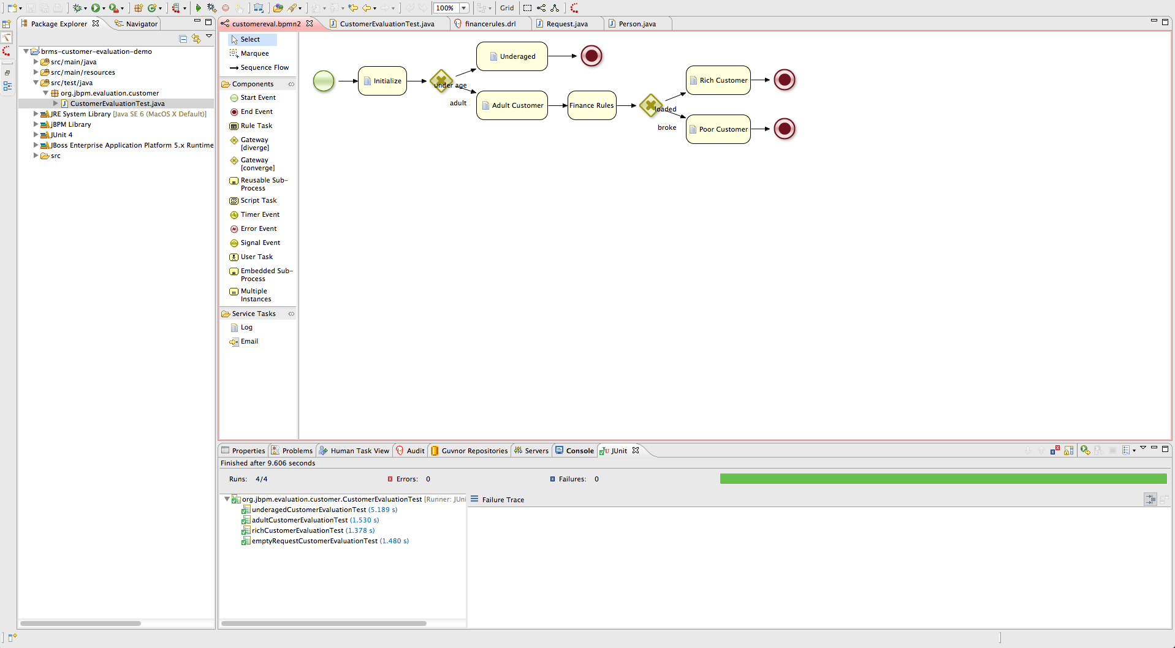Illustration 1: Unit Tests in JBoss Dev Studio
Your output should look something like illustration 1 and example output of the console logging:
Test 1
=========================================
= Starting Process Underaged Test Case. =
=========================================
Entering Initialize Node
Leaving Initialize Node
Gateway: Qualify Age
Gateway: Qualify Age
Entering Underaged Node
Detected and reporting invalid request.
Set validRequest to: false
Leaving Underaged Node
Process ended in End Minor Node.

Test 2
==========================================
= Starting Process Poor Adult Test Case. =
==========================================
Entering Initialize Node
Leaving Initialize Node
Gateway: Qualify Age
Gateway: Qualify Age
Entering Adult Customer Node
Detected and reporting valid request
Set validRequest to: true
Leaving Adult Customer Node
Entering Finance Rules Node
Under funded customer
Set Request invalid comment to: Poor customer.
Customer request= org.jbpm.evaluation.customer.Request@31
Leaving Finance Rules Node.
Gateway: Decide Financial Status
Determined request is NOT valid, heading to Poor Customer Node
Request validity reason is: Poor customer
Leaving Finance Rules Node.
Gateway: Decide Financial Status
Detected request is invalid, heading to Poor Customer Node
Request not valid reason is: Poor customer
Entering Poor Customer Node
Customer has amount: 2 in the bank.
Leaving Poor Customer Node
Process ended in End Poor Customer Node.

Test 3
==========================================
= Starting Process Rich Adult Test Case. =
==========================================
Entering Initialize Node
Leaving Initialize Node
Gateway: Qualify Age
Gateway: Qualify Age
Entering Adult Customer Node
Detected and reporting valid request
Set validRequest to: true
Leaving Adult Customer Node
Entering Finance Rules Node
Leaving Finance Rules Node.
Gateway: Decide Financial Status
Determined request is valid, heading to Rich Customer Node
Entering Rich Customer Node
Detected and reporting valid request
Customer has amount: 2000 in the bank.
Leaving Rich Customer Node
Process ended in End Rich Customer Node.

Test 4
=============================================
= Starting Process Empty Request Test Case. =
=============================================
Entering Initialize Node
There as no evaluation objects defined, adding default ones for demo purposes.
Leaving Initialize Node
Gateway: Qualify Age
Gateway: Qualify Age
Entering Underaged Node
Detected and reporting invalid request.
Set validRequest to: false
Leaving Underaged Node
Process ended in End Minor Node.

BRMS BRM demo
The package was already imported so now we can look closer at web designers viewing, rules asset viewing, package building and deploying, web business central admin console viewing.

Web Designer
The BRM is available on http://localhost:8080/jboss-brms once the BRMS server has been fully started.
- Login with a user (admin, krisv, mary, john, erics available). To start fresh you can at any time import the original repository as follows: Administration → Import Export → Choose File ->brms-customer-evaluation-demo/support/repository-export.zip → Import (Ok to pop-ups)
- View process: Knowledge Bases → Packages → org.jbpm.evaluation.customer → Asset tab → view Processes and Open customereval and wait for web designer to appear.

Rule asset viewing
To view some of the assets in your project:
- Knowledge Bases → Packages → org.jbpm.evaluation.customer → Asset tab → view Technical Rule Assets, Model, Processes, Other assets or WorkItemDefinition.

Build package for deployment
To build your package for deployment:
- Build package: Knowledge Bases → Packages → org.jbpm.evaluation.customer → Edit tab → Build Package button. Now the process has been deployed in the Business Central administration component.

Business Central
The Business Central administration console is available on http://localhost:8080/business-central once the BRMS server has been fully started and after deploying your process by building the package in BRMS BRM.
- Login as user (admin, erics, krisv have same rights).
- On left open Processes tab → Process Overview and you should see Customer Evaluation Demo appear. If not, hit Refresh. If not, ensure the demo package has been built without errors in BRM as described previously.
- Click on Customer Evaluation Demo to select this process, then Start button and OK for pop-up.
- As this process has no pausing nodes, no human tasks for example, it will complete and show you nothing except the following in the Server log (note, this is one of the unit test outputs for an empty submission to the process):
12:53:26,937 INFO [STDOUT] Entering Initialize Node
12:53:26,937 INFO [STDOUT] There as no evaluation objects defined, adding default ones for demo purposes.
12:53:26,941 INFO [STDOUT] Leaving Initialize Node
12:53:26,944 INFO [STDOUT] Gateway: Qualify Age
12:53:26,944 INFO [STDOUT] Gateway: Qualify Age
12:53:26,947 INFO [STDOUT] Entering Underaged Node
12:53:26,947 INFO [STDOUT] Detected and reporting invalid request.
12:53:26,949 INFO [STDOUT] Set validRequest to: false
12:53:26,949 INFO [STDOUT] Leaving Underaged Node
12:53:26,949 INFO [STDOUT] Process ended in End Minor Node.

